**Project Documentation: Expense Request Approval Process**

Name: Shaik Javeed Ahammad

**1. Introduction**

Managing expenses in an organization is a crucial process. Traditionally, employees submit requests for purchases, which are manually checked against budgets, approved or rejected by managers, and then communicated back. This manual approach is **time-consuming**, **error-prone**, and **inefficient**.

This project implements a **Salesforce Record-Triggered Flow** that automates the **approval/rejection process based on expense category and amount**, and sends an email to the requester using **Send Email action** (without using a template).

**Objectives:**

* Automate approvals for category-based expenses
* Notify requesters immediately via email
* Minimize manual intervention
* Keep the object and flow simple (Name, Amount, Category, Status)

**2. Salesforce Org Setup**

**Step 1: Sign Up / Login**

* Go to https://trailhead.salesforce.com
* Login with your credentials, or create a **Developer Edition org** for testing

**Step 2: Navigate to Setup**

* Click **Gear Icon → Setup**
* Use **Quick Find → Object Manager** to create custom objects

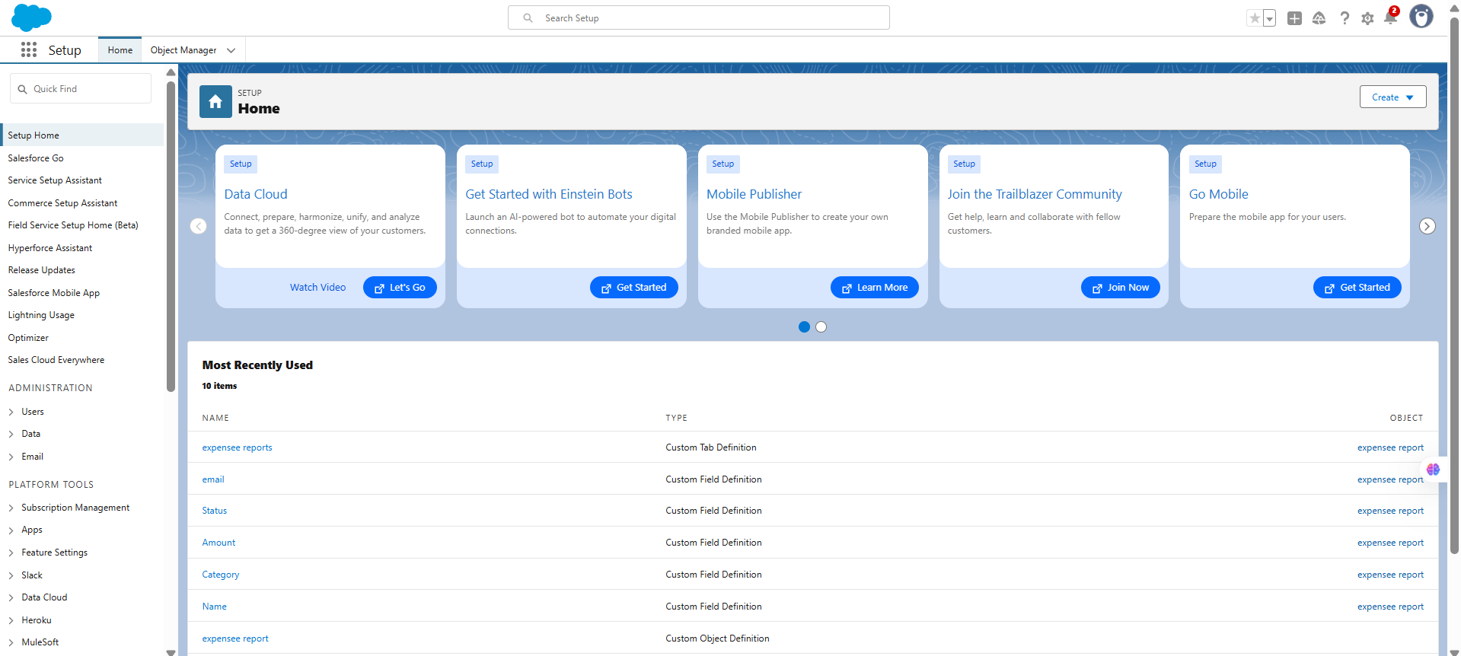

**3. Create Custom Object: Expense_Report__c**

**Steps:**

1. In **Setup → Object Manager → Create → Custom Object**
2. Fill details:
   * Label: Expense Report
   * Plural Label: Expense Reports
   * Object Name: Expense_Report__c
   * Record Name: Name (Text)
3. Leave optional features unchecked for simplicity
4. Save object

**Create Fields:**

* **Amount__c**
  + Data Type: Currency
  + Label: Amount
  + Length & Decimal: 16, 2
* **Category**
  + Data Type: Picklist
  + Values: Veggies, Groceries, Clothing, Savings, Travel, Cosmetics
* **Status__c**
  + Data Type: Picklist
  + Values: Submitted, Approved, Not Approved

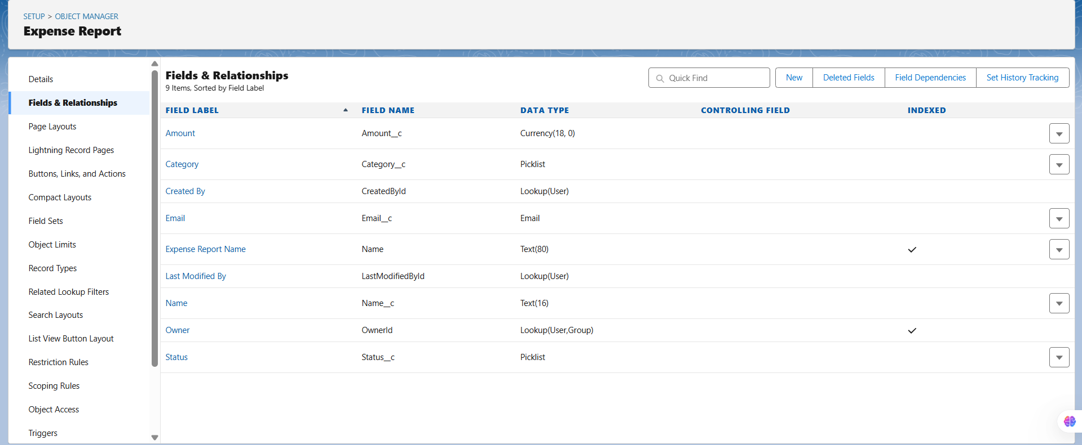

**4. Build Record-Triggered Flow**

**Step 1: Go to Flow Builder**

* Setup → Flow → New Flow → **Record-Triggered Flow**
* Object: Expense_Report__c
* Trigger: **When a record is created**
* Entry Condition: None (all new records trigger flow)
* Optimize for: Actions and Related Records
* Click **Done**

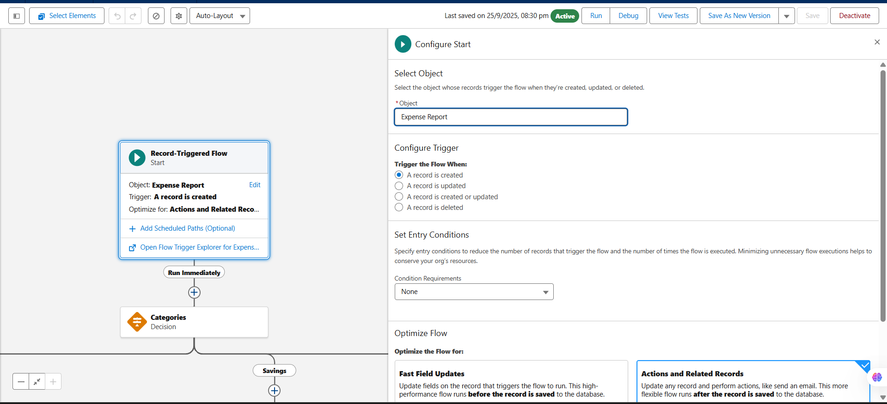

**Step 2: Add Decision Element – Category + Amount**

**Element Name:** Categories

**Purpose:** Directs flow based on Category and Amount

**Outcomes:**

In this Expense Request Approval Flow, each expense category is assigned a maximum allowable amount to determine automatic approval or rejection. For example, “Veggies” has a limit of ₹500, “Groceries” ₹2000, “Clothing” ₹4000, “Savings” ₹8000, “Travel” ₹6000, and “Cosmetics” ₹5000. When a request is submitted, the Flow evaluates both the category and the requested amount: if the amount is within the set limit, the Status field is updated to “Approved” and an approval email is sent to the requester; if the amount exceeds the limit, the Status is set to “Not Approved” and a rejection email is triggered. This structured approach ensures that all requests are handled consistently, minimizes manual intervention, and keeps users informed in real-time about the outcome of their expense requests.

|  |  |  |  |  |  |  |  |  |  |  |  |  |  |  |  |  |  |  |  |  |  |  |  |  |  |  |  |  |  |  |  |  |  |  |  |  |  |  |  |  |  |  |
| --- | --- | --- | --- | --- | --- | --- | --- | --- | --- | --- | --- | --- | --- | --- | --- | --- | --- | --- | --- | --- | --- | --- | --- | --- | --- | --- | --- | --- | --- | --- | --- | --- | --- | --- | --- | --- | --- | --- | --- | --- | --- | --- |
| |  |  |  |  |  |  | | --- | --- | --- | --- | --- | --- | | **Category** | **Maximum Amount** | **Status if ≤ Max** | **Status if > Max** | **Email Message if Approved** | **Email Message if Rejected** | | Veggies | 500 | Approved | Not Approved | “Your expense request of amount {!Amount__c} has been approved under Veggies.” | “Your expense request of amount {!Amount__c} exceeds the allowed budget for Veggies.” | | Groceries | 2000 | Approved | Not Approved | “Your expense request of amount {!Amount__c} has been approved under Groceries.” | “Your expense request of amount {!Amount__c} exceeds the allowed budget for Groceries.” | | Clothing | 4000 | Approved | Not Approved | “Your expense request of amount {!Amount__c} has been approved under Clothing.” | “Your expense request of amount {!Amount__c} exceeds the allowed budget for Clothing.” | | Savings | 8000 | Approved | Not Approved | “Your expense request of amount {!Amount__c} has been approved under Savings.” | “Your expense request of amount {!Amount__c} exceeds the allowed budget for Savings.” | | Travel | 6000 | Approved | Not Approved | “Your expense request of amount {!Amount__c} has been approved under Travel.” | “Your expense request of amount {!Amount__c} exceeds the allowed budget for Travel.” | | Cosmetics | 5000 | Approved | Not Approved | “Your expense request of amount {!Amount__c} has been approved under Cosmetics.” | “Your expense request of amount {!Amount__c} exceeds the allowed budget for Cosmetics.” | |

**Notes:**

* Default outcome handles unexpected categories
* Name outcomes descriptively (e.g., “Veggies – Approved”)

**Step 3: Update Records Element**

* Drag **Update Records** onto each branch (Approved/Rejected)
* Update **Status__c**:
  + Approved branch → Status__c = Approved
  + Rejected branch → Status__c = Not Approved

**Important:** Update occurs **before** sending the email to ensure correct status is included.

**Step 4: Send Email Action (No Template)**

* Drag **Action → Send Email** after Update Records
* Configuration:
  + **Recipient:** User email or a configured email field
  + **Subject:** Expense Request Status
  + **Body:** Use HTML in the action itself

**Example for Approval:**

<p>Hello, your expense request of amount {!Amount__c} has been approved under the {!Category} category.</p>

<p>You may proceed with your purchase.</p>

**Example for Rejection:**

<p>Hello, your expense request of amount {!Amount__c} exceeds the allowed budget for the {!Category} category.</p>

<p>Please review and adjust your request.</p>

**Tips:**

* Use merge fields directly in flow {!Amount__c}, {!Category}
* Email subject can also include merge fields if desired

**5. Testing**

**Step 1: Create Test Records**

* Go to **Expense Reports → New**
* Enter different combinations of Category and Amount

**Step 2: Verify Flow Execution**

|  |  |  |  |  |
| --- | --- | --- | --- | --- |
| **Test Case** | **Category** | **Amount** | **Expected Status** | **Email Output** |
| 1 | Veggies | 450 | Approved | “Amount 450 approved under Veggies.” |
| 2 | Veggies | 650 | Not Approved | “Amount 650 exceeds allowed budget for Veggies.” |
| 3 | Travel | 6000 | Approved | “Amount 6000 approved under Travel.” |
| 4 | Travel | 6100 | Not Approved | “Amount 6100 exceeds allowed budget for Travel.” |
| 5 | Clothing | 4000 | Approved | “Amount 4000 approved under Clothing.” |
| 6 | Clothing | 4500 | Not Approved | “Amount 4500 exceeds allowed budget for Clothing.” |

**Edge Cases:**

* Category blank → Default Outcome → Not Approved
* Amount = exact limit → Approved

**6. Error Handling**

* **Status not updating:** Ensure Update Records element runs **before** Send Email
* **Email not received:** Check user email deliverability and spam folder
* **Merge fields blank:** Verify API names match {!Amount__c} and {!Category}
* **Unexpected category:** Default outcome prevents flow failure

**7. Benefits**

* Fully automated approval/rejection based on Category + Amount
* Instant email notification without templates
* Minimal user input (Name, Amount, Category)
* Scalable for future enhancements
* Reduces human error and improves efficiency

**8. Future Enhancements**

* Add Manager approval for high-value requests
* Conditional routing for different departments
* Include attachments (e.g., receipts)
* Create reporting dashboards
* Make flow mobile-friendly for submissions

**9. Conclusion**

This **full Category + Amount-based Expense Flow** automates approval/rejection and sends email notifications directly via **Send Email action**.

**Key Highlights:**

* Simple object: Name, Amount, Category, Status
* Flexible flow branching for multiple categories
* Emails dynamically generated based on outcome
* Error handling for robust execution
* Scalable, easy to maintain, ready for production